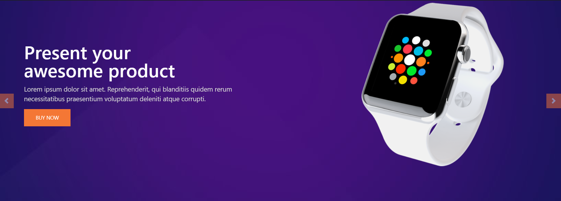
SampleSite

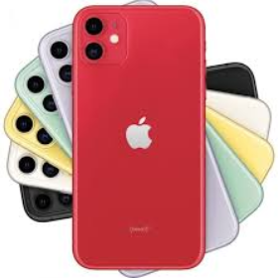
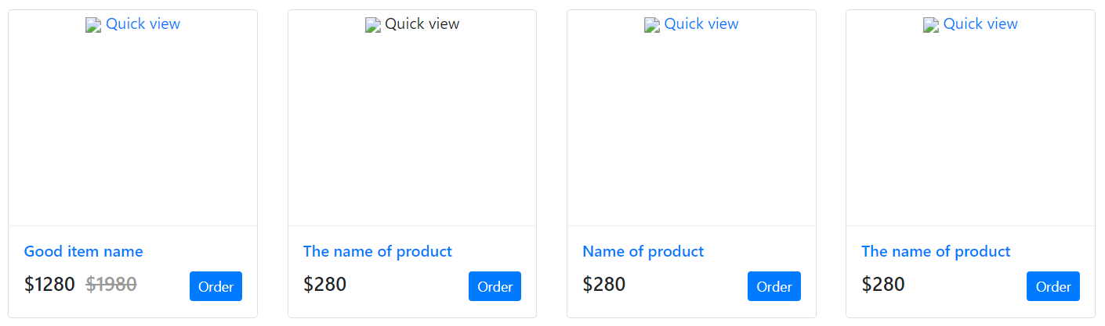











Create a product object/json object.
Sample json object.
{
"product": [{
"name": "iphone 11",
"brand": "apple",
"description": "iphone 11",
"price": "280"

},
{
"name": "iphone 11",
"brand": "apple",
"description": "iphone 11",
"price": "280"
},
{
"name": "iphone 11",
"brand": "apple",
" description": "iphone 11",
"price": "280"
}
]
}

- don’t use jQuery or any library.
- don’t use css framework like bootstrap, foundation or materials.

